**Assignment 4**

**Planning System Development: Career Path Finder**

**Systems Concepts, Analysis and Design**

**INFO8003 - Fall 2024**

**Professor - Amandeep Kaur**



**Submitted by:**

Karishma Sheik - 9029019

Neha Gupta - 8974495

Sai sravan kumar repaka - 9000820

Akhil Tatikonda – 8972335

Table of Contents

**Executive Summary** 3

**Forming an Agile Development Team** 4

**Preliminary Research** 6

**AI-Powered Research Process** 6

**Brain-Storming:** 7

**Research-Web Market Analysis** 8

**Technical Requirements** 12

**1. Functional Requirements** 12

**Non-Functional Requirements** 15

**Testing and Quality Assurance** 18

**Documentation** 18

**Deployment and Maintenance** 18

**Use Cases** 21

**1. Supplier Registration** 22

**2. Digital Marketplace** 23

**3. Business Analytics** 23

**4. AI-powered Recommendations** 24

**5. Integrated Digital Marketing Tools** 24

**6. Networking Hub** 25

**7. Sustainability Module** 25

**8. Payment Gateway Integration** 26

**9. Feedback System** 27

**Activity Diagram** 32

**Entities** 33

**Prototypes** 37

**Class Diagram** 38

**Implementation - Developing the Agile Plan** 39

**Conclusion** 39

# **Executive Summary**

BizBridge is a comprehensive platform designed to connect small business suppliers with large marketplaces, empowering them with growth, collaboration, and sustainability tools. The project is being implemented using an Agile Scrum framework across three iterative sprints, focusing on delivering core functionalities such as Supplier Registration, Digital Marketplace, Business Analytics, and Networking Hub. The team ensures scalability, adaptability, and rigorous testing by leveraging modern technologies like Node.js, React.js, and MongoDB, creating a robust, user-friendly platform that bridges the gap between small businesses and broader markets.

# **Forming an Agile Development Team**

|  |  |  |  |
| --- | --- | --- | --- |
| **Task** | **Designation** | **Team Member** | **Roles and Responsibilities** |
| Brainstorming | Team Lead, Product Owner | Akhil (A), Karishma (B), Neha (C), Sravan (D) | Generate ideas and feature requirements. |
| Research | Researcher, Business Analyst | Akhil (A) | Collect data on market trends, competition, and needs. |
| Business Model | Business Analyst | Neha (N) | Develop value proposition, revenue streams, and cost model. |
| Market Analysis | Business Analyst, Researcher | Akhil (A) | Identify target users and market opportunities. |
| Use Cases | System Analyst | Neha (N) | Define user interactions with the system. |
| Entity Relationship Diagram | System Architect | Sravan (S) | Define relationships between data entities. |
| Activity Diagram | System communication | Saravan (S) | Define communication between use cases |
| Class Diagram | Software Developer | Neha (N) | Model application classes. |
| Content Plans | Content Writer, UX Designer | Karishma (K) | Plan promotional and informational material. |
| Prototype Mockups | UX/UI Designer | Akhil (A) | Create visual design for key features. |
| Code Development | Software Developer | Karishma (K) ,Neha (N) | Implement features and functionality. |
| Testing (Unit, Integration, Regression, Acceptance and Usability) | QA Engineer | Sravan (D) | Conduct thorough testing at all stages. |
| Documentation | Technical Writer | Karishma (K) ,Neha (N) | Prepare user manuals, help guides, and project documentation. |

**Agile Roles:**

|  |  |  |
| --- | --- | --- |
| Role | Team Member | Responsibilities |
| Product Owner | Karishma | Define product vision, prioritize backlog, and represent stakeholders. |
| Scrum Master | Neha | Facilitate Agile processes, remove impediments, and ensure team productivity. |

# **Preliminary Research**

## **AI-Powered Research Process**

**Prompts Used:**

1."What features are essential in a platform connecting small business suppliers with large marketplaces?"

2."What are best practices for designing business analytics tools for small businesses?"

3."How can AI-powered recommendations improve small business operations?"

4."What makes a networking hub effective for business collaboration?"

5."What strategies can small businesses use to promote sustainability in their operations?"

**Adaptations:**

* Insights were tailored to align with the BizBridge goals, ensuring relevance to target users and project objectives.
* Adjustments were made to avoid overly technical or impractical implementations for small business users.

**Appendix: AI Prompts**

**Prompt 1:** "Generate a list of features for a digital marketplace tailored to small businesses."

**Prompt 2:** "Explain how to implement a business analytics module with graphs and charts for a small business platform."

**Prompt 3:** "Provide examples of successful networking hub designs for online platforms."

**Prompt 4:** "Describe AI algorithms that can recommend partnerships and marketing strategies based on user activity."

**Prompt 5:** "What metrics can small businesses track to demonstrate sustainability in their operations?"

By integrating these research findings and AI-generated insights, the BizBridge project ensures its features address real-world business needs while remaining adaptable and innovative.

# **Brain-Storming:**

**Concept & Brainstorming:**

BizBridge is a comprehensive platform that connects small business suppliers with large business chains and online shopping platforms, integrating digital media for enhanced visibility and networking. The app empowers suppliers with tools to expand their business reach, enabling entrepreneurship, promoting sustainability, and improving facilities planning.

**Relation to Key Themes:**

1. **Entrepreneurship:**

* Support Growth: Provides a platform for small businesses to connect with larger chains, facilitating scalability.
* Empower Innovation: Encourages suppliers to innovate products/services to meet market demands.
* Business Insights: Offers analytics to help small businesses identify opportunities and optimize operations.

1. **Sustainability**:
   * **Local Sourcing:** Promotes local suppliers, reducing transportation costs and carbon emissions.
   * **Resource Optimization:** Suggests sustainable practices for packaging and delivery.
   * **Green Certification:** Partners with eco-friendly initiatives to encourage sustainable business operations.

**3. Facilities Planning:**

* **Inventory Management:** Integrates tools for suppliers to manage inventory in real-time.
* **Logistics Coordination:** Provides scheduling features for deliveries and pickups.
* **Space Optimization:** Recommends storage and workspace utilization strategies.

# **Research-Web Market Analysis**

**Alibaba**

Alibaba is one of the world’s largest online business-to-business (B2B) platforms connecting suppliers (mainly from China) with businesses worldwide.

**Features:**

* + Supplier Search: Businesses can find suppliers by category, country, and other filters.
  + Product Listings: Suppliers can upload their products with details, prices, and contact information.
  + Trade Assurance: Protects transactions between suppliers and buyers.
  + Messaging and Orders: Suppliers and businesses can communicate and place orders directly.

**Differentiation:** Alibaba mainly serves global buyers and sellers, and the platform is more focused on product transactions than supplier visibility and network growth.

**ThomasNet**

ThomasNet is a platform focused on industrial suppliers and service providers. It connects manufacturers and businesses with suppliers across various industries in the U.S.

**Features:**

* + Supplier Directories: Businesses can search for suppliers based on industry, location, and product type.
  + Request for Quote (RFQ): Business chains can send RFQs to suppliers for competitive bidding.
  + CAD Drawings: Suppliers can upload CAD drawings and specifications for parts.
  + Supplier Ratings: Suppliers are rated based on customer reviews.

**Differentiation:**

ThomasNet focuses mainly on industrial suppliers, and the marketplace is less diverse in terms of product types.

**Alternative Solutions/Apps**

While BizBridge specifically focuses on the connection between small business suppliers and large business chains, existing platforms like Alibaba, Amazon Business, and ThomasNet already cater to a similar audience. However, they prioritize the transactional side rather than fostering visibility, networking, and entrepreneurship for suppliers.

**Freelancer Platforms (Fiverr, Upwork):**

Suppliers can use these platforms to showcase their products, connect with clients, and build networks. However, these platforms are more service-oriented than focused on physical goods and supply chain management.

**Features for BizBridge**

* Supplier Visibility: Tools for suppliers to enhance their visibility (e.g., featured listings, SEO optimization, and social media integration).
* Networking and Community: Digital media integration to allow networking between small business suppliers and large business chains.
* Sustainability Tools: Highlight eco-friendly or sustainable suppliers, providing a sustainability score and certification tools.
* Product and Transaction Management: Tools for businesses to manage orders, quotes, and transactions.
* Educational Resources for Suppliers: Provide entrepreneurial resources, including business planning and financial forecasting tools for suppliers to grow their businesses.

**Why Develop BizBridge?**

Developing BizBridge makes sense because it fills a gap in the B2B market by combining digital media integration, visibility tools, and entrepreneurial support in one platform. Existing applications primarily focus on transactional features, leaving small suppliers with limited tools for growth and networking. BizBridge addresses this gap by offering a platform that enhances supplier branding, allows for sustainability tracking, and provides business development tools to ensure the growth and success of small business suppliers.

Combining these features, BizBridge is positioned to serve a unique and underserved market, offering B2B connections and supplier empowerment.

**Description:**

**BizBridge: Empowering Small Businesses Through Connection**

BizBridge is a smart and easy-to-use platform designed to help small business suppliers grow by connecting them with big business chains and online shopping platforms. It creates opportunities for small businesses to showcase their products, find buyers, and build partnerships that help them succeed. With features like a digital marketplace, business analytics, AI-powered recommendations, and integrated marketing tools, BizBridge makes it simple for suppliers to manage their business and reach more customers. The app also promotes sustainability by encouraging eco-friendly practices and provides a secure payment system for safe transactions. BizBridge is more than just a platform—it’s a community where businesses can connect, grow, and thrive.

**Features:**

1. **Supplier Registration**: Easy onboarding for small businesses with profile customization.
2. **Digital Marketplace: S**howcase products to potential buyers with detailed descriptions, media, and ratings.
3. **Business Analytics:** Reports on sales, demand trends, and customer demographics.
4. **AI-powered Recommendations**: Suggests partnerships, products, and marketing strategies.
5. **Integrated Digital Marketing Tools:** 
   1. Social media integration for campaigns.
   2. Automated ads to increase visibility.
6. **Networking Hub**: Forums for suppliers and buyers to share insights and opportunities.
7. **Sustainability Module: Tr**acks and promotes eco-friendly practices.
8. **Payment Gateway Integration**: Secure options for transactions.
9. **Feedback System:** Allows buyers and suppliers to rate and review each other.

# **Technical Requirements**

## **1. Functional Requirements**

**User Registration:**

Allow suppliers and business chains to create accounts using email or social media logins (Google, Facebook).

Collect necessary data such as name, business type, location, and contact information during registration.

**User Login:**

Implement a secure login system using JWT (JSON Web Tokens) or OAuth for token-based authentication.

Support both password-based authentication and social login methods.

**User Roles:**

Suppliers: Access to product management, visibility settings, and performance analytics.

Business Chains/Online Platforms: Ability to browse suppliers, evaluate products, and initiate transactions.

Admin: Manage users, content, and application settings.

**Supplier Dashboard**

**Profile Management:**

Allow suppliers to manage and update their business information, including business name, description, contact details, and product catalog.

**Product Listings:**

Suppliers can upload and manage products, including product name, description, price, quantity, images, and category.

Enable inventory tracking and real-time stock updates.

**Visibility and Promotion:**

Tools for suppliers to enhance product visibility, including featured products, advertisement banners, and SEO optimization.

Integration with social media platforms for marketing purposes.

**Business Chain Dashboard**

**Search and Browse Suppliers:**

Search functionality with filters based on product category, location, price range, and supplier rating.

Product recommendations based on previous interactions or preferences.

**Supplier Evaluation:**

Ability to rate and review suppliers based on criteria like product quality, delivery time, and customer service.

Access to supplier analytics such as performance history, product ratings, and sales figures.

**Transaction Management:**

Request quotes from suppliers and manage orders.

Track order statuses and payment histories.

**Analytics and Reporting**

**Supplier Analytics:**

Dashboard to show supplier performance metrics, such as sales growth, product views, conversion rates, and customer feedback.

**Business Chain Analytics:**

Tools for business chains to analyze supplier performance and trends, including cost per acquisition, profit margins, and inventory performance.

**Communication and Networking**

**Messaging System:**

Real-time chat functionality for suppliers and business chains to discuss products, negotiate pricing, and clarify orders.

Push notifications to alert suppliers about inquiries and order statuses.

**Social Media Integration:**

Allow suppliers to connect their business profiles to social media accounts (e.g., Instagram, Facebook) to promote products.

**Sustainability and Entrepreneurship Support**

**Sustainability Indicators:**

Track carbon footprint and eco-friendly practices of suppliers.

Display certifications such as organic, fair trade, or environmentally responsible for suppliers that comply with sustainability standards.

**Entrepreneurial Tools:**

Provide suppliers with access to business planning tools, financial forecasting, and educational content related to growing a sustainable business.

## **Non-Functional Requirements**

**Performance and Scalability**

The platform should be highly scalable to support an increasing number of users, product listings, and transactions.

Latency must be minimal, especially for real-time features like messaging and transaction updates.

Load Balancing and caching mechanisms should be implemented to handle traffic spikes during sales or promotional events.

**Security**

Data Encryption: Ensure SSL/TLS encryption for all user data and transactions.

Data Protection: Store sensitive data, such as passwords, using strong hashing algorithms like bcrypt.

Authorization: Implement role-based access control (RBAC) to restrict access to specific functionalities based on the user role.

Payment Security: Integrate secure payment gateways (e.g., Stripe, PayPal) for transaction processing.

**Accessibility**

The platform must adhere to WCAG 2.1 guidelines for accessibility, including:

Text resizing

Keyboard navigation

Alt text for images

Accessible forms with labels

Ensure compatibility with screen readers for visually impaired users.

**Cross-Platform Compatibility**

The platform should be responsive and function smoothly across devices (desktop, tablet, mobile).

Implement progressive web app (PWA) features to allow offline usage and improved performance on mobile devices.

**Localization and Language Support**

The platform must support multiple languages and currencies, especially if operating in diverse geographical regions.

Include a language switcher for users to choose their preferred language.

**Technical Stack**

**Frontend Technologies**

React.js or Vue.js for dynamic, single-page application (SPA) development.

Redux (for React) or Vuex (for Vue.js) for state management.

HTML5 and CSS3 for the layout and structure, with SASS or Styled-components for advanced styling.

Bootstrap or Tailwind CSS for responsive design and components.

**Backend Technologies**

Node.js with Express.js for building RESTful APIs to handle user requests, transactions, and data interactions.

MongoDB or PostgreSQL for database management, depending on the data structure and relationships (NoSQL for flexible data models, SQL for structured data).

JWT (JSON Web Tokens) for stateless authentication.

Socket.io for real-time communication (e.g., messaging and order tracking).

**Payment Integration**

Stripe or PayPal API for secure payment processing.

**Hosting and Cloud Services**

Amazon Web Services (AWS) or Google Cloud Platform (GCP) for scalable cloud hosting and storage.

Docker for containerization, enabling consistent environments across development and production.

**User Experience (UX) and Design**

**Visual Design**

A clean, modern design with intuitive navigation to ensure users can easily access key features (e.g., product listings, messaging, transactions).

Use minimalistic design principles with emphasis on product visibility and supplier discovery.

Prioritize mobile-first design to ensure excellent user experience on smartphones.

**Interactive Elements**

Interactive Dashboards with dynamic charts and real-time data for both suppliers and business chains.

Drag-and-drop interfaces for easier product listing management.

## **Testing and Quality Assurance**

**Functional Testing**

Test all core features, including user registration, login, product management, search and filtering, messaging, and transactions.

**Usability Testing**

Conduct user testing to ensure the application is intuitive and accessible for both suppliers and business chains.

**Performance Testing**

Use tools like Google Lighthouse and Apache JMeter to test the platform’s load time, scalability, and responsiveness under varying user loads.

**Security Testing**

Conduct regular penetration testing to ensure that the application is secure against common web vulnerabilities such as SQL injection, XSS, and CSRF.

## **Documentation**

Code Documentation: Provide detailed inline comments and explanations for key sections of the code.

API Documentation: Include a well-documented Swagger API specification for backend services.

User Documentation: Provide a user guide that explains how to use the app, including account creation, product management, and transaction processes.

## **Deployment and Maintenance**

Use CI/CD pipelines (e.g., GitHub Actions, CircleCI) for continuous integration and automated testing during development.

Implement log management and error tracking with services like Sentry to monitor the app’s performance in real-time and quickly address bugs.

**Personas**

**Persona-1**

**Persona-2**

**Persona-3**

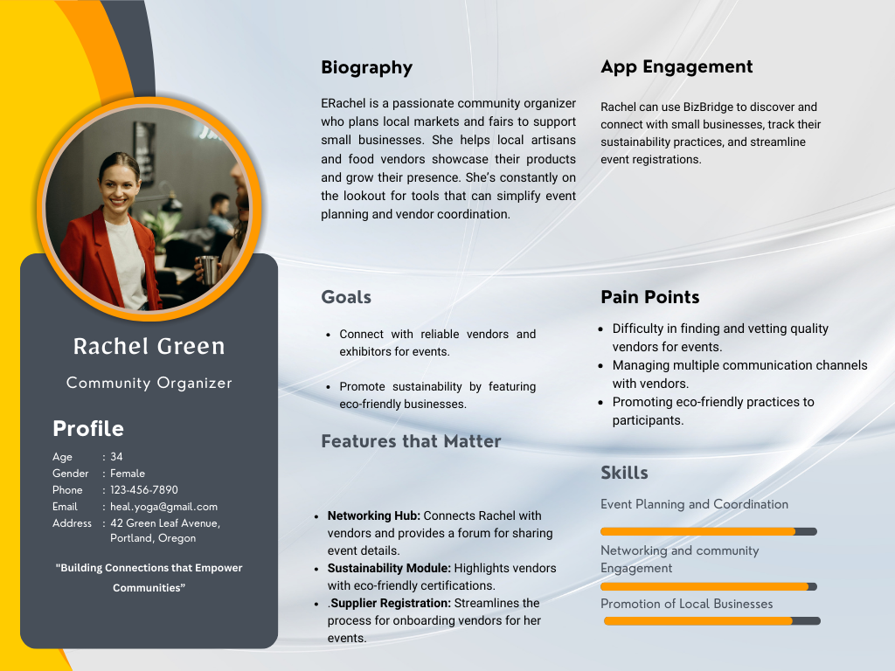

# **Use Cases**

**1. Supplier Registration**

**Actors: Small Business Owner, System Admin**

**Use Cases:**

1. **Supplier Registration**

Description: A small business owner creates an account by providing company details, contact information, and products offered.

1. **Verify Supplier Account**

Description: The system admin reviews and approves supplier accounts to ensure authenticity.

1. **Customize Supplier Profile**

Description: Suppliers add branding elements, such as logos, banners, and custom descriptions, to enhance their profile.

Here’s a detailed list of potential **use cases** for each feature, along with associated actors and descriptions:

### **1. Supplier Registration**

**Actors:** Small Business Owner, System Admin  
**Use Cases:**

1. **Register as a Supplier**
   * **Description:** A small business owner creates an account by providing company details, contact information, and products offered.
2. **Verify Supplier Account**
   * **Description:** The system admin reviews and approves supplier accounts to ensure authenticity.
3. **Customize Supplier Profile**
   * **Description:** Suppliers add branding elements, such as logos, banners, and custom descriptions, to enhance their profile.

### **2. Digital Marketplace**

**Actors:** Supplier, Buyer  
**Use Cases:**

1. **Add Product to Marketplace**
   * **Description:** Suppliers list their products with descriptions, images, videos, and pricing information.
2. **Search Products**
   * **Description:** Buyers search for products using filters like category, price range, or location.
3. **View Product Details**
   * **Description:** Buyers view comprehensive product information, including reviews and ratings.

### **3. Business Analytics**

**Actors:** Supplier, System  
**Use Cases:**

1. **Generate Sales Reports**
   * **Description:** Suppliers receive analytics on sales performance, including top-selling products and revenue trends.
2. **View Customer Demographics**
   * **Description:** Suppliers access data on customer profiles, locations, and buying habits.
3. **Track Demand Trends**
   * **Description:** The system identifies high-demand products based on buyer activity.

### **4. AI-powered Recommendations**

**Actors:** Supplier, Buyer  
**Use Cases:**

1. **Recommend Partnerships**
   * **Description:** The AI suggests potential partnerships between suppliers and buyers based on product compatibility.
2. **Suggest Marketing Strategies**
   * **Description:** AI provides personalized marketing strategies for suppliers, such as recommended ad placements and campaigns.
3. **Product Recommendations for Buyers**
   * **Description:** Buyers receive tailored suggestions for products based on their search and purchase history.

### **5. Integrated Digital Marketing Tools**

**Actors:** Supplier, Digital Marketing System  
**Use Cases:**

1. **Create Social Media Campaigns**
   * **Description:** Suppliers design and schedule marketing campaigns with integrated templates.
2. **Track Campaign Performance**
   * **Description:** The system provides metrics on campaign engagement, clicks, and conversions.
3. **Launch Automated Ads**
   * **Description:** Suppliers use the system to create automated ad campaigns targeting specific buyer demographics.

### **6. Networking Hub**

**Actors:** Supplier, Buyer  
**Use Cases:**

1. **Post Discussion Topics**
   * **Description:** Suppliers or buyers start threads to discuss business opportunities, challenges, or industry trends.
2. **Join Forums**
   * **Description:** Actors participate in forums to network and exchange ideas.
3. **Direct Messaging**
   * **Description:** Suppliers and buyers use a built-in messaging system to establish direct communication.

### **7. Sustainability Module**

**Actors:** Supplier, Sustainability Advisor (System)  
**Use Cases:**

1. **Track Eco-friendly Practices**
   * **Description:** Suppliers input and monitor their sustainability metrics, like carbon footprint and recyclable materials used.
2. **Earn Green Certification**
   * **Description:** Suppliers receive certifications for meeting sustainability standards and improving their market appeal.
3. **Receive Sustainability Suggestions**
   * **Description:** The system provides actionable insights to improve environmental practices.

### **8. Payment Gateway Integration**

**Actors:** Supplier, Buyer, Payment Processor  
**Use Cases:**

1. **Process Payments**
   * **Description:** Buyers make secure payments for products purchased from suppliers.
2. **Set Up Payment Methods**
   * **Description:** Suppliers configure payment options such as credit card, PayPal, or direct bank transfers.
3. **View Transaction History**
   * **Description:** Suppliers and buyers review past transactions for accounting and record-keeping purposes.

### **9. Feedback System**

**Actors:** Supplier, Buyer  
**Use Cases:**

1. **Rate Supplier/Buyer**
   * **Description:** Buyers rate suppliers based on product quality and service; suppliers rate buyers for reliability.
2. **Write Reviews**
   * **Description:** Actors provide detailed feedback on their experience, visible to others in the system.
3. **Resolve Feedback Disputes**
   * **Description:** The system or admin mediates disputes over negative feedback between parties.

* The 2 use cases chosen for use case description are:

1.Business Analytics

2.Network Hub

**Use Case:1**

|  |  |
| --- | --- |
| **Attribute** | **Details** |
| **Use Case ID** | UC-001 |
| **Use Case Name** | Generate Business Analytics Reports |
| **Actors** | Supplier, System |
| **Preconditions** | - The supplier must have an active account. |
| - The supplier must have at least one transaction recorded. |
| **Postconditions** | - The system generates detailed analytics reports and displays them in the supplier dashboard. |
| **Normal Flow** | 1. The supplier logs into the BizBridge platform. |
| 2. The supplier navigates to the "Analytics" section. |
| 3. The supplier selects the desired report type (e.g., sales, trends, customer demographics). |
| 4. The system retrieves and processes the data. |
| 5. The system displays the analytics report with visual representations (charts, graphs). |
| **Alternative Flow** | |  | | --- | | 4a. If no data is available, the system displays a message indicating insufficient data to generate reports. |  |  | | --- | |  | |
| **Exceptions** | - Network failure during data retrieval leads to an error message, prompting the user to retry. |
| |  | | --- | | **Triggers** |  |  | | --- | |  | | - Supplier clicks on the "Generate Report" button. |
| **Priority** | High |
| **Frequency of Use** | Regular |
| |  | | --- | | **Assumptions** |  |  | | --- | |  | | - Suppliers understand basic data interpretation. |
|  | |

**Use Case:2**

|  |  |  |  |  |  |
| --- | --- | --- | --- | --- | --- |
| |  | | --- | | **Attribute** |  |  | | --- | |  | | |  | | --- | | **Detais** |  |  | | --- | |  | |
| |  | | --- | | **Use Case ID** |  |  | | --- | |  | | |  | | --- | | UC-002 |  |  | | --- | |  | |
| |  | | --- | | **Use Case Name** |  |  | | --- | |  | | |  | | --- | | Post Discussion in Networking Hub |  |  | | --- | |  |  |  | | --- | |  |  |  | | --- | |  | |
| |  | | --- | | **Actors** |  |  | | --- | |  | | |  | | --- | | Supplier, Buyer, System |  |  | | --- | |  | |
| |  | | --- | | **Preconditions** |  |  | | --- | |  | | |  | | --- | | - The actor must have an active account. |  |  | | --- | |  | |
|  | |  | | --- | | - The actor must be logged into the platform. |  |  | | --- | |  | |
| |  | | --- | | **Postconditions** |  |  | | --- | |  | | |  | | --- | | - The discussion post is visible in the networking hub for others to view and comment on. |  |  | | --- | |  | |
| |  | | --- | | **Normal Flow** |  |  | | --- | |  | | |  | | --- | | 1. The actor logs into the BizBridge platform. |  |  | | --- | |  | |
|  | |  | | --- | | 2. The actor navigates to the "Networking Hub" section. |  |  | | --- | |  | |
|  | |  | | --- | | 3. The actor clicks on "New Post" and enters a discussion title and content. |  |  | | --- | |  | |
|  | |  | | --- | | 4. The actor submits the post. |  |  | | --- | |  | |
|  | |  | | --- | | 5. The system verifies and publishes the post in the networking hub. |  |  | | --- | |  | |
| |  | | --- | | **Alternative EU Flow** |  |  | | --- | |  | | |  | | --- | | 4a. If the post contains restricted content, the system displays an error message requesting corrections. |  |  | | --- | |  | |
| |  | | --- | | **Exceptions** |  |  | | --- | |  | | |  | | --- | | - A system error while submitting the post prevents it from being published. |  |  | | --- | |  | |
| |  | | --- | | **Triggers** |  |  | | --- | |  | | |  | | --- | | - The actor clicks on the "Submit Post" button. |  |  | | --- | |  | |
| |  | | --- | | **Priority** |  |  | | --- | |  | | |  | | --- | | Medium |  |  | | --- | |  | |
| |  |  |  | | --- | --- | --- | | |  | | --- | | **Frequency of Use** |  |  | | --- | |  | | |  |  |  | | --- | |  | | |  | | --- | | Occasional |  |  | | --- | |  | |
| Assumptions | |  | | --- | | - Users will follow community guidelines when posting discussions. |  |  | | --- | |  | |
|  | |

# **Activity Diagram**

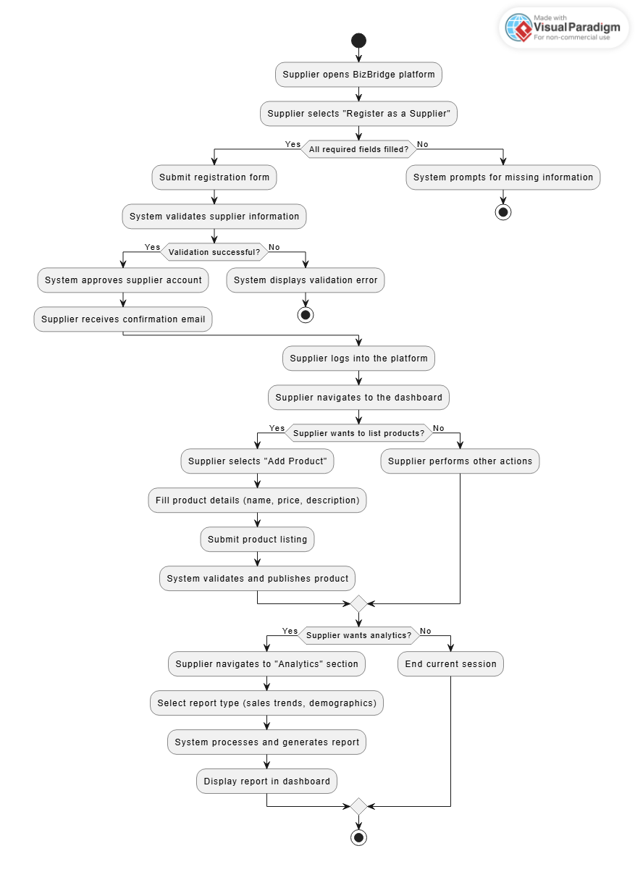

# **Entities**

**Content Plan**

The content plan will detail the textual and interactive elements included in BizBridge to ensure a seamless user experience. It outlines the features, inputs, outputs, and visual design for the application’s key pages aiding further prototyping.

**1. Home Page**

**Purpose:** Introduce BizBridge, highlight its benefits, and encourage users to sign up.

**Text Content:**

**Tagline:** "Empowering Small Businesses Through Connection."

**Brief introduction:** Explains BizBridge’s purpose and key features.

**Call-to-action:** “Join the Marketplace,” “Explore Features.”

**Supporting content:** Benefits of connecting small businesses to large chains, sustainability focus.

**Visual Content:**

Hero banner with impactful imagery of small businesses and their products.

**Buttons:** “Sign Up” and “Learn More.”

Infographics or icons highlighting core features like networking, analytics, and sustainability.

**2. Registration Page**

**Purpose:** Onboard suppliers quickly and securely.

**Text Content:**

**Form labels:** “Business Name,” “Contact Information,” “Product Categories.”

**Instructions:** “Complete the form to join BizBridge.”

**Call-to-action:** “Register Now.”

**Visual Content:**

Simple, uncluttered form layout.

Confirmation message on successful registration: “Welcome to BizBridge!”

**3.Supplier Dashboard**

**Purpose:** Provide suppliers with tools to manage their profile, products, analytics, and networking.

**Text Content:**

Personalized welcome message: “Welcome back, [Supplier Name].”

**Section titles:** “Manage Your Marketplace,” “View Analytics,” “Connect with Buyers.”

Instructions for navigating features like adding products and viewing reports.

**Visual Content:**

Interactive cards for actions: “Add Product,” “Generate Report,” “Post in Network Hub.”

Graphs and charts for business analytics (e.g., sales trends, customer demographics).

**4. Networking Hub**

**Purpose:** Facilitate communication between suppliers and buyers.

**Text Content:**

Section introduction: “Engage with buyers and fellow suppliers in real-time.”

**Buttons:** “Start a Discussion,” “Message a Buyer,” “Join a Forum.”

Placeholder text in input fields for posts or messages.

**Visual Content:**

Discussion threads with user avatars, timestamps, and post previews.

Direct messaging interface with chat bubbles and file upload options.

**5. Product Listing Page (Marketplace)**

**Purpose:** Showcase products for buyers to browse and purchase.

**Text Content:**

Product titles and descriptions.

Filters and sorting options (e.g., “By Category,” “By Price”).

**Call-to-action:** “Add to Cart,” “Contact Supplier.”

**Visual Content:**

Product images and videos.

Rating and review stars under product listings.

Pagination or infinite scrolling for browsing.

**6. Analytics Page**

**Purpose:** Provide suppliers with actionable insights to grow their business.

**Text Content:**

Section introduction: “Understand your business with detailed analytics.”

Labels for charts and graphs: “Sales Trends,” “Top Products,” “Customer Demographics.”

**Call-to-action:** “Download Report,” “View More Details.”

**Visual Content:**

Line charts for sales trends, pie charts for customer demographics.

Icons or metrics for key stats (e.g., total sales, returning customers).

**7. Sustainability Module**

**Purpose:** Encourage and track eco-friendly practices among suppliers.

**Text Content:**

**Section introduction:** “Promote sustainability in your business.”

**Certification progress bar:** “Steps to Earn Green Certification.”

**Tips and suggestions:** “Switch to recyclable packaging,” “Optimize delivery routes.”

**Visual Content:**

Progress tracker showing steps toward green certification.

Badges or labels for certified eco-friendly suppliers.

**8. Payment Page**

**Purpose:** Enable secure transactions between buyers and suppliers.

**Text Content:**

**Form labels:** “Card Details,” “Billing Address.”

**Call-to-action:** “Pay Now.”

**Error messages:** “Invalid Payment Details.”

**Visual Content:**

Payment gateway logo icons (e.g., Visa, Mastercard, PayPal).

A confirmation screen with an order summary and transaction ID.

# **Prototypes**

**Prototype - 1**

**Prototype-2**

# **Class Diagram**

# **Implementation - Developing the Agile Plan**

Iteration Plan_Agile Backlog and Release Summary_Bizbridge.xlsx

# **Conclusion**

BizBridge is a transformative platform connecting small business suppliers with larger marketplaces, fostering growth, collaboration, and sustainability. Built using an Agile Scrum approach and modern technologies, it integrates key features like Business Analytics and AI-powered Recommendations to deliver a scalable, user-friendly solution. BizBridge empowers small businesses to thrive in a competitive digital landscape while promoting innovation and eco-friendly practices.